**BCDE102 Assessment 3 Daniel Wild**

**Iteration 4**

**WHERE:**

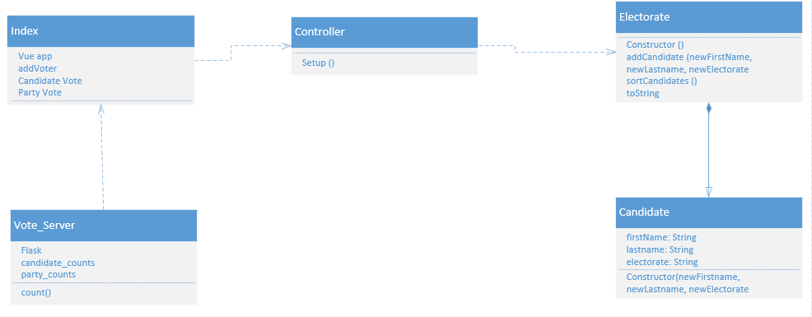

**WHAT:**

The goal of iteration 4 is to take data from the results of the 2017 NZ election to create bar and pie graphs to visualise the total number of votes and the percentage of votes using Chart JS.

The Tasks:

1. Learn Chart JS using powerpoints from old students
2. Install Chart JS
3. Create the charts using the election data
4. Create unit tests to test the charts

Task Time Estimates

1. Learn Chart JS using powerpoints from old students: 30 minutes
2. Install Chart JS: 10 Minutes
3. Create the charts using the election data: 1 hour
4. Create unit tests to test the charts: 1 hour

Estimated Total Time: 2 hours 40 minutes

Planned product

Task Times

1. Learn Chart JS using powerpoints from old students : 10 Minutes
2. Install Chart JS: 10 Minutes
3. Create the charts using the election data: 2 hours
4. Create unit tests to test the charts: 2 Hours

Total Time: 4 hour 20 minutes

**How:**

Unit tests

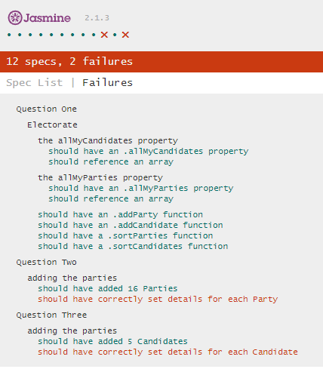JS

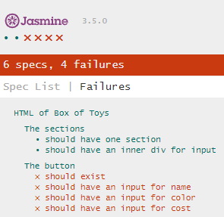HTML

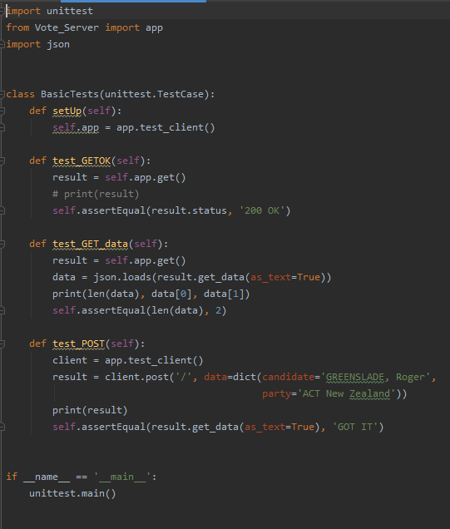Python

User Stories

I am a voter from Wairarapa I want to be able to see the candidates and parties I can vote for. I want to be able to vote for only one of each party and candidate.

I am a new New Zealand voter I want to be able to see the explanation for each vote I am able to make and have a clear form that is easy to read.

I am a vote counter with admin rights I want to be able to see the total number of votes that have been submitted for each candidate and each party.

I am a candidate I want to know what the total number of votes there were and find out who won.

I am a Wairarapa voter who wants to see the results of the last election

Burndown Chart

Activity diagram

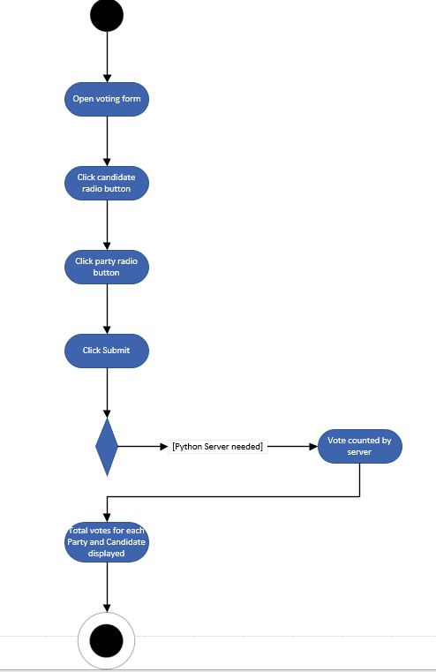

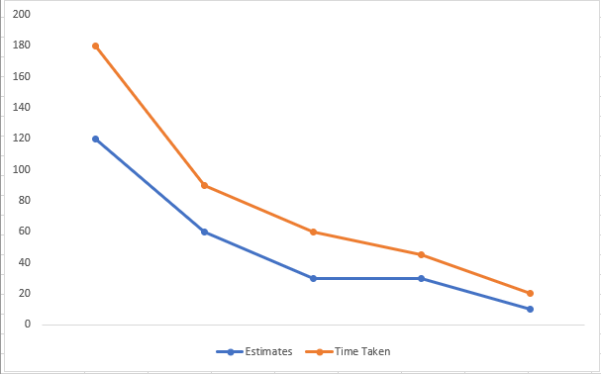

**Evaluation:**

Style

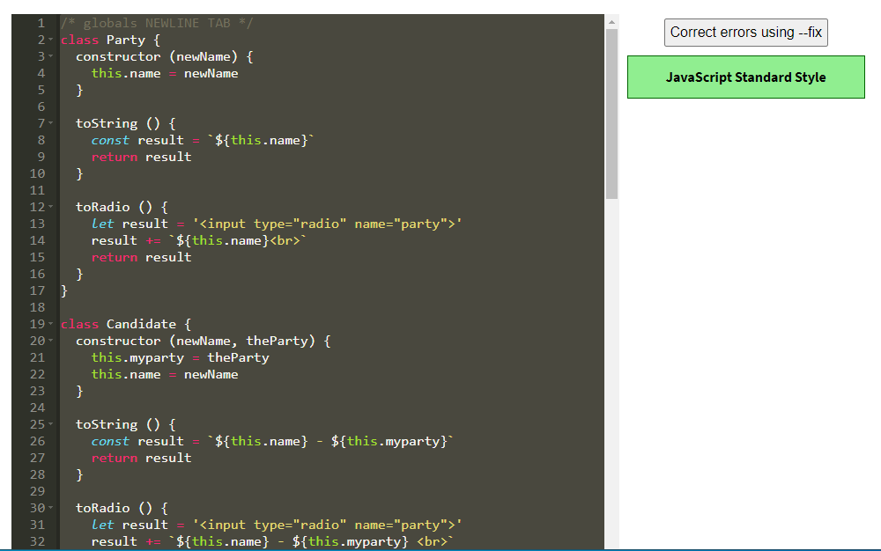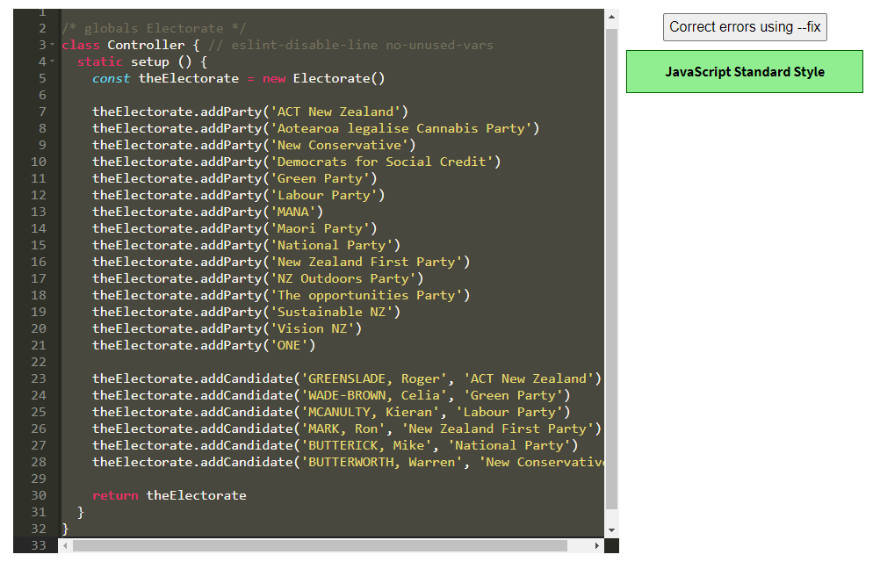 JS

HTML Index.html

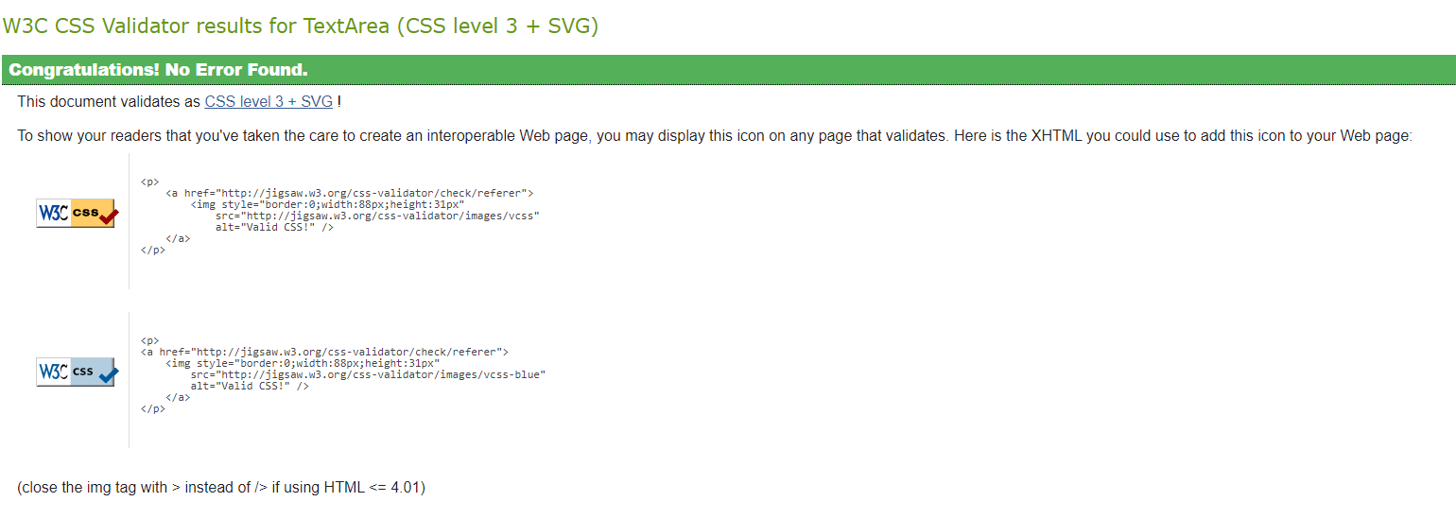HTML Election 2017.html

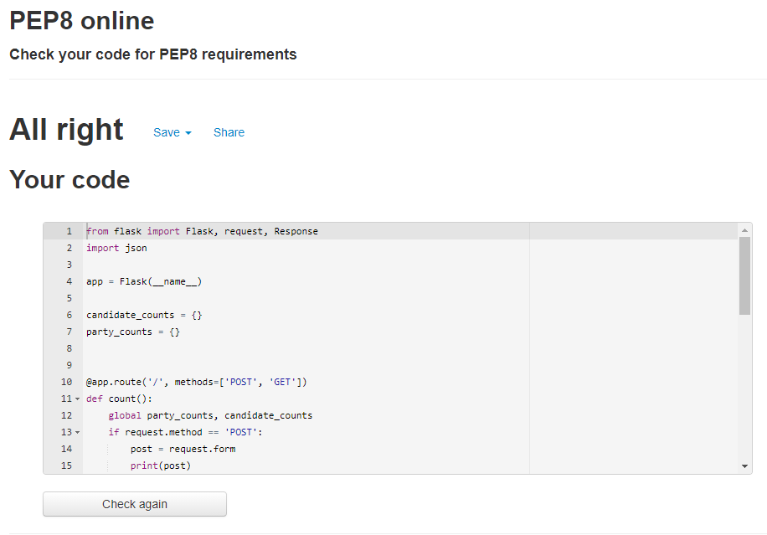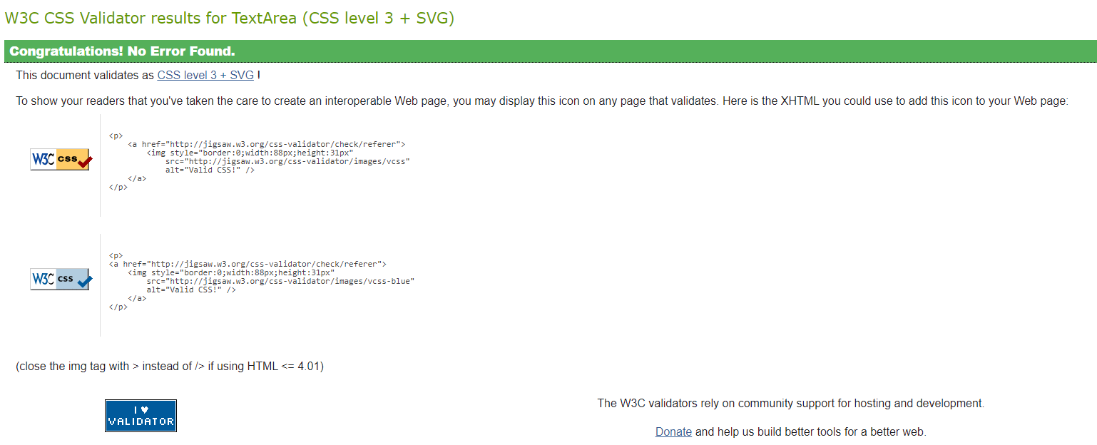Python

**What happened vs what was planned:**

The goal of iteration 4 was to use the data from the 2017 election to create a separate html page that was linked to the election 2020 vote page that would show the voter the result in Wairarapa from the last election using Chart JS and use html jasmine tests to make sure the charts existed and had the right data. Creating the charts was easy and worked well and it was easy to link the two pages together. The unit tests were a problem and I could not get them to work in the spec runner at all.

**Performance Review:**

Using Chart JS and creating the graphs worked well and I was able to link the HTML pages but I struggled with the unit test and could not get them to work. I’ve run into problems with the unit tests on a lot of the interactions and it is the thing I need to work on the most.